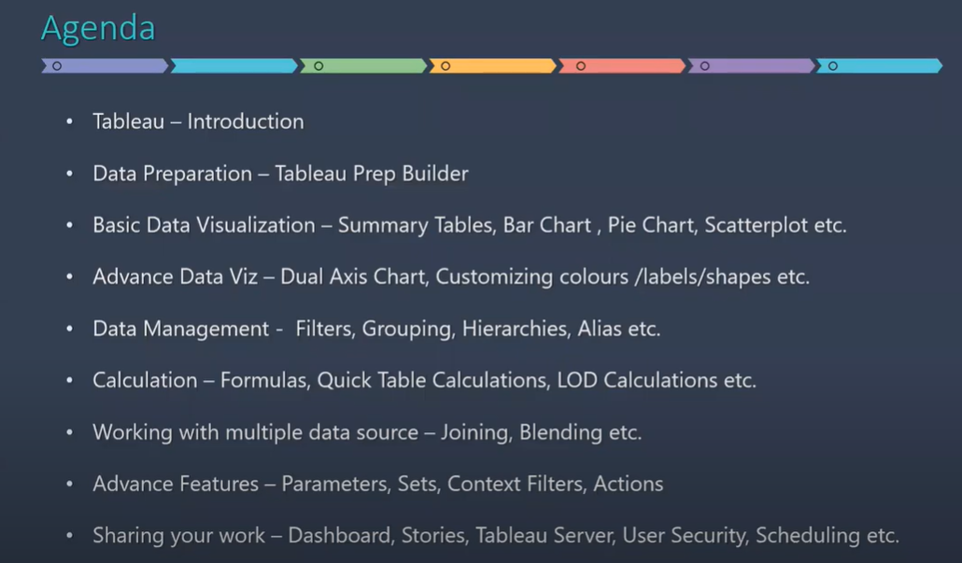

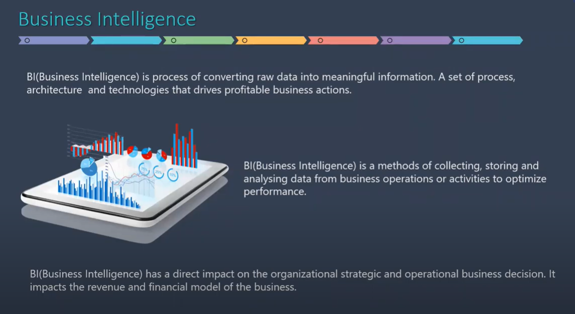

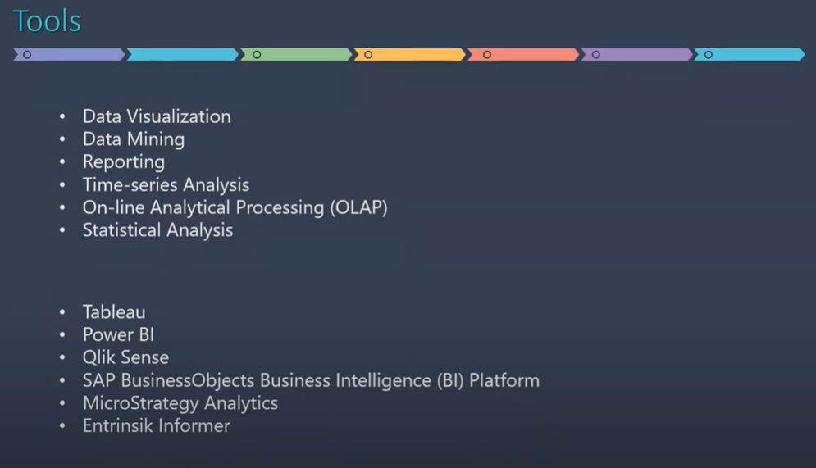

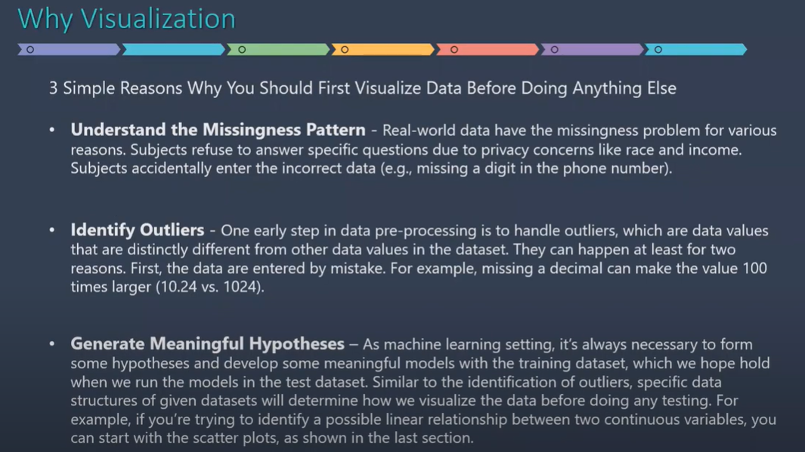

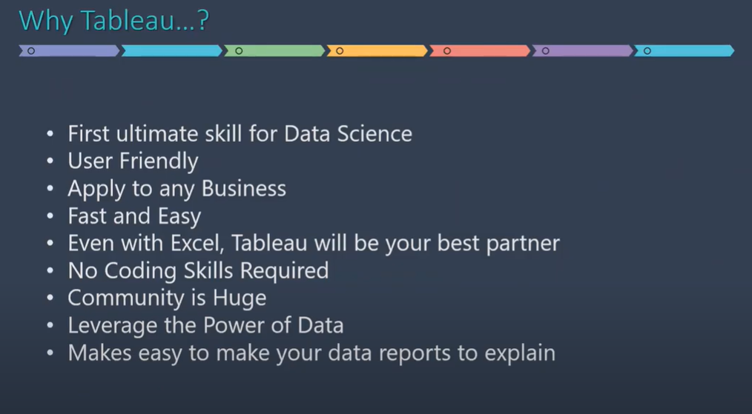

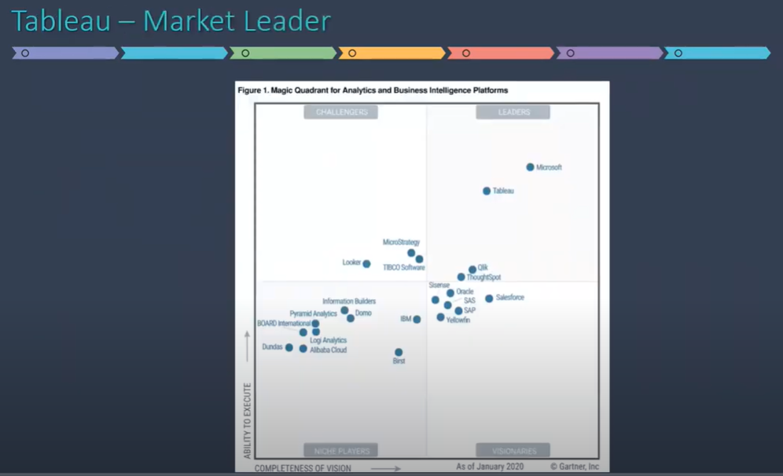

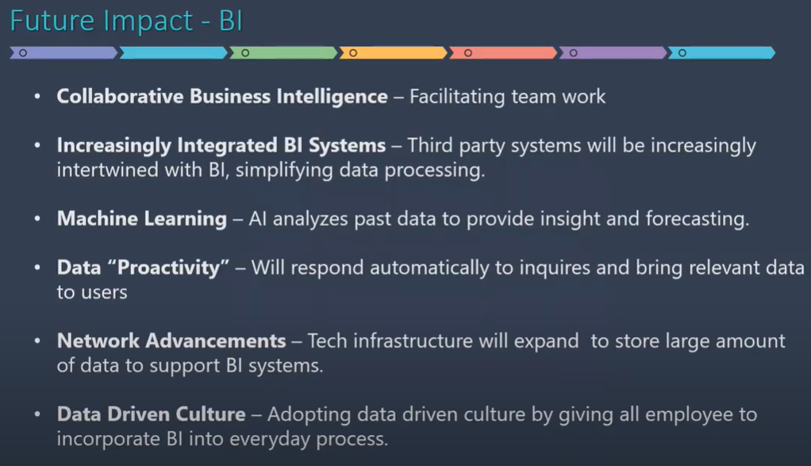

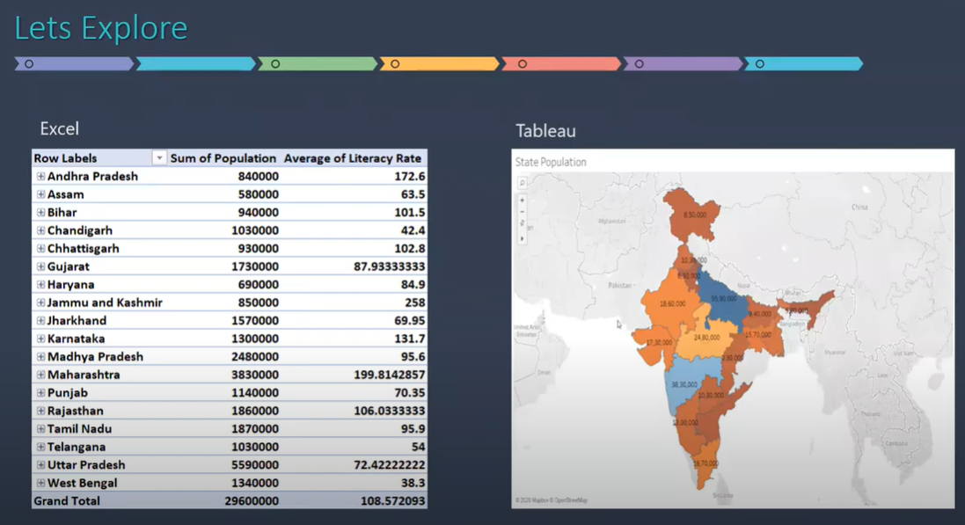

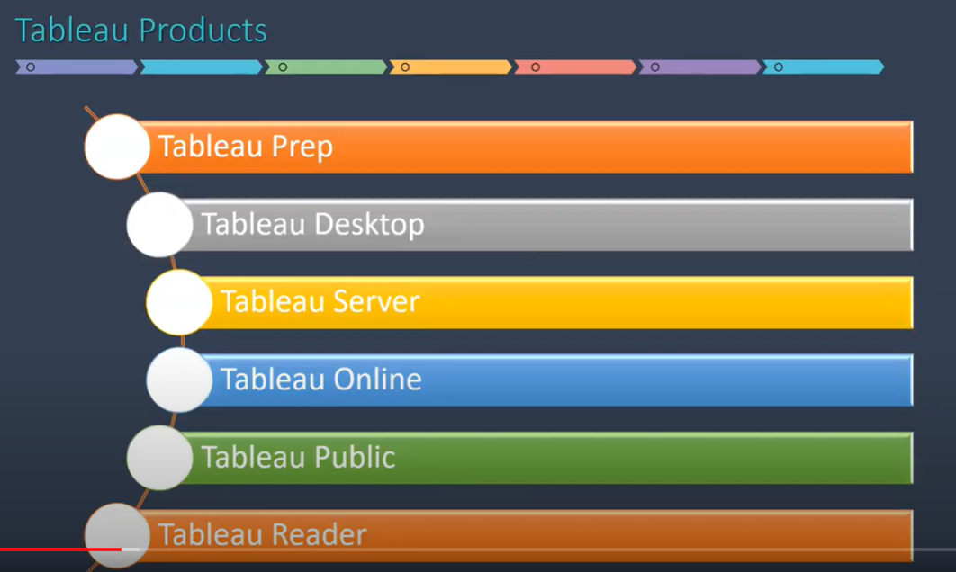

Tableau official site for its products:



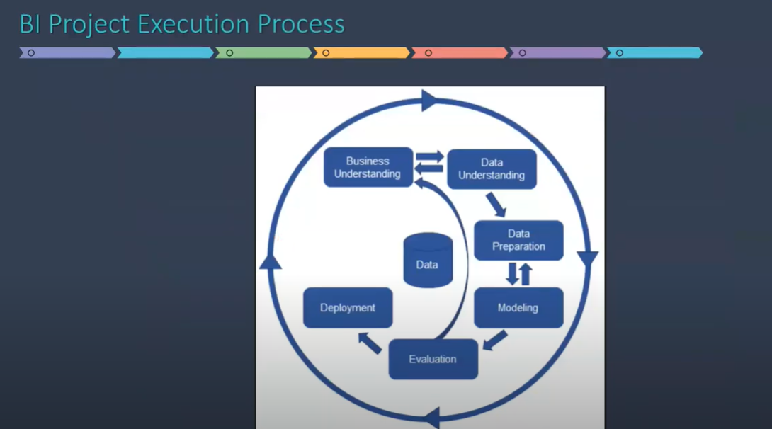

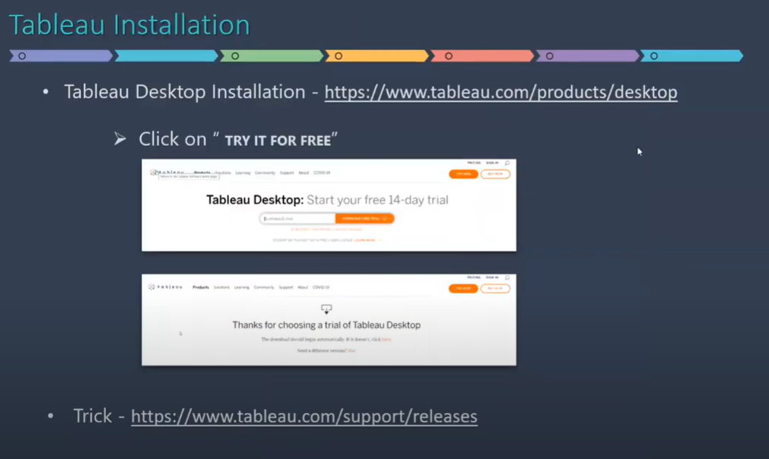

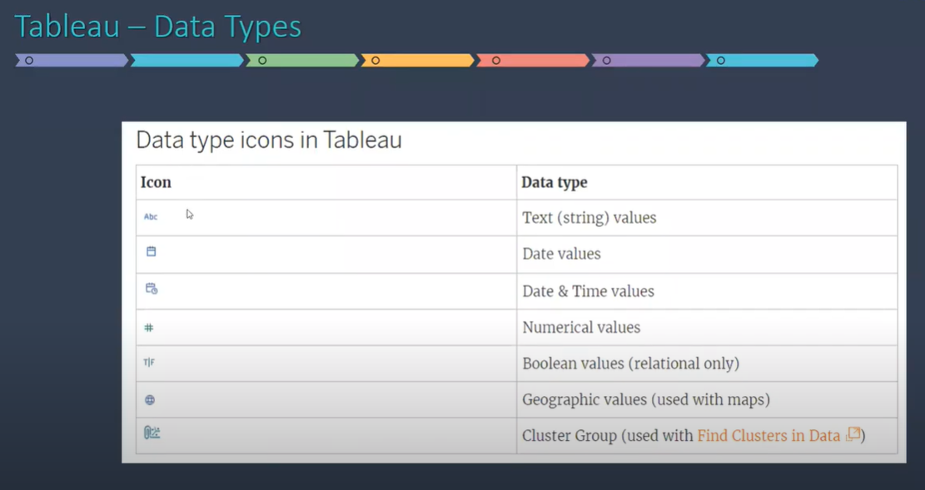

There are three different ways in which we can access the dimensions and measures in Tableau:

* + Drag and drop
  + Double click
  + Point and click (most commonly used)

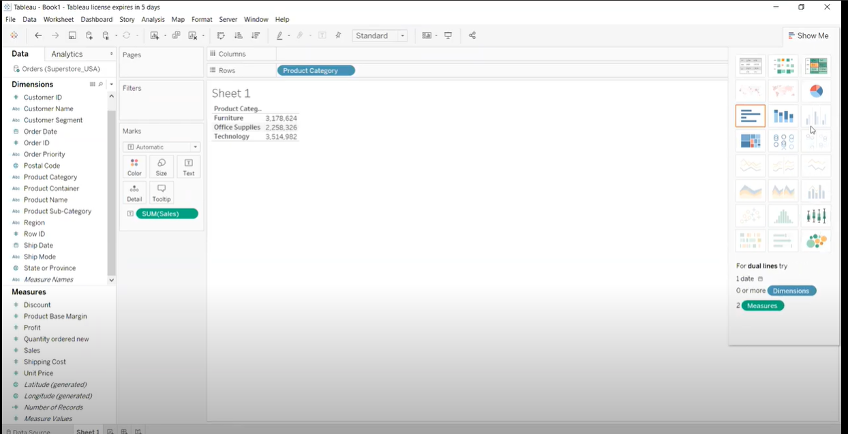

Some visuals are highlighted and some are greyed out. Tableau is intelligent enough to let you know what kinds of visuals can be used with given data. Out of all the highlighted visuals, one has orange border so that’s the best suited visual.

**Saving the report to Tableau Public:**

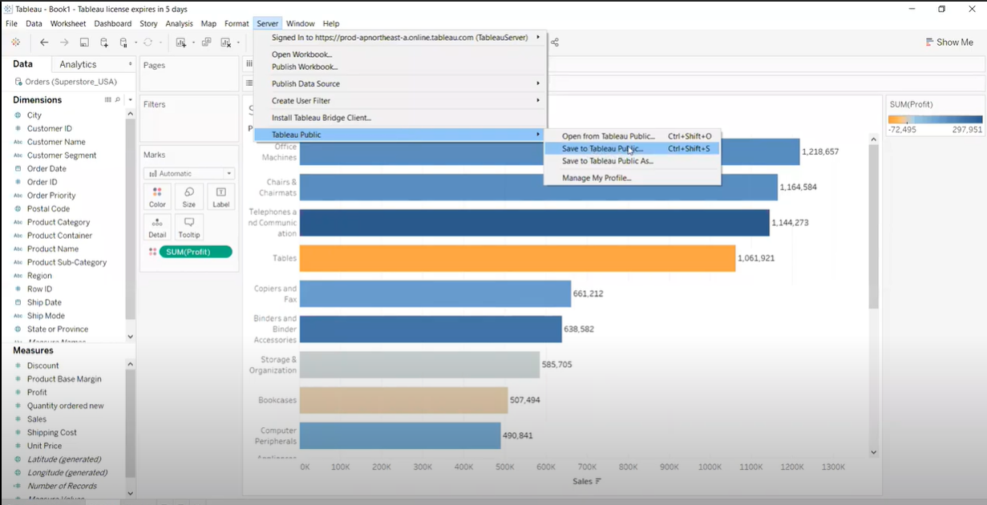

**Import the dataset: Superstore_USA**

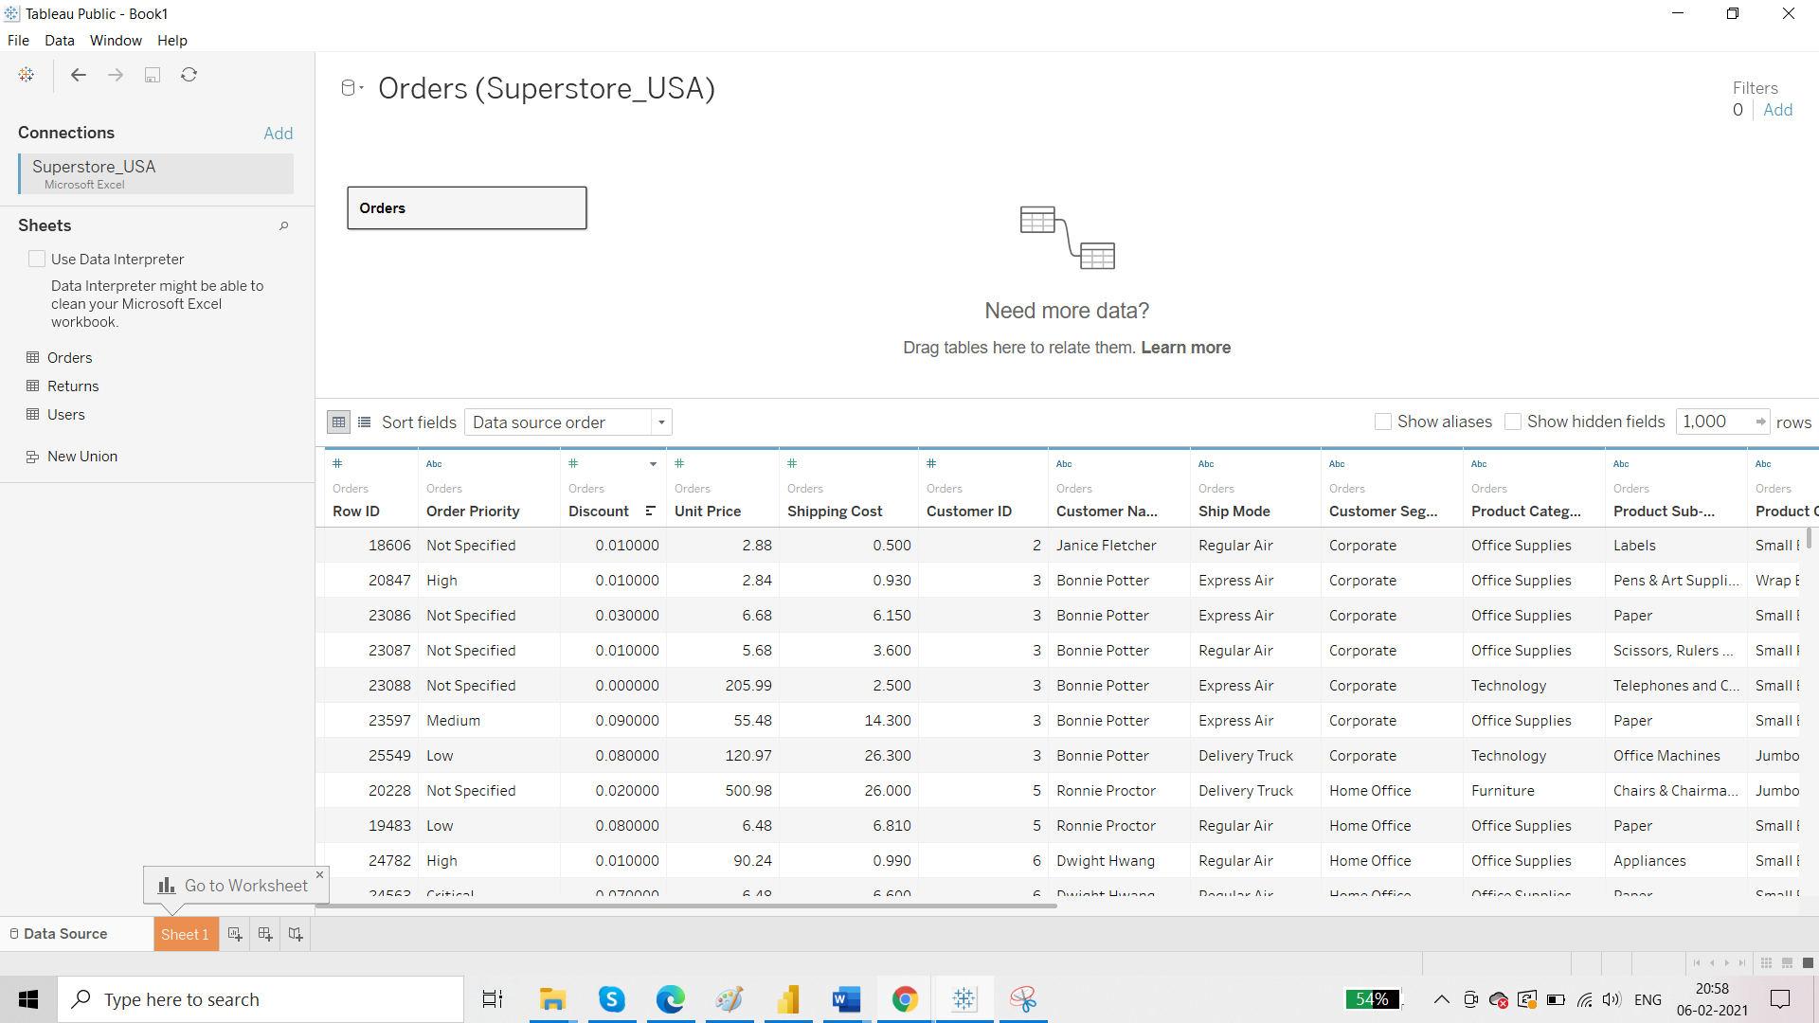

Tableau allows 2 types of connection:

* Live
* Extract

If you click on Extract and click on sheet1, Tableau will prompt you to save this data into your system. The format that tableau uses is .hyper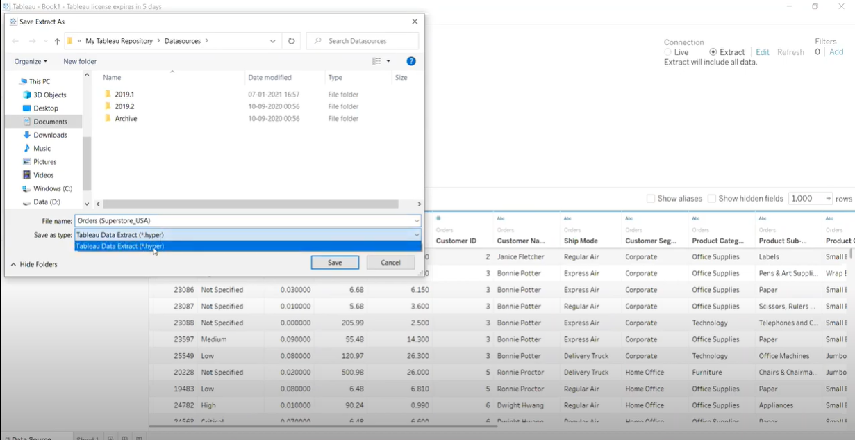

**Tableau Online tips: Extracts, live connections, & cloud data**

[SHARE](https://www.tableau.com/about/blog/2016/4/tableau-online-tips-extracts-live-connections-cloud-data-53351)

In our [last tip](https://www.tableau.com/about/blog/2016/3/tableau-online-tips-5-quick-ways-kick-start-your-cloud-analytics-experience-52642), we gave you five quick ways to get up and running with Tableau Online. In this post, we’ll explore the difference between data extracts and live connections, and when to use them. We’ll also look at publishing data sources to Tableau Online.

Data extracts vs. live connections

“Extract” is a word you’re going to hear a lot in Tableau. Extracts are one of the most powerful but overlooked tools in Tableau’s arsenal.

Tableau Data Extracts are snapshots of data optimized for aggregation and loaded into system memory to be quickly recalled for visualization. Extracts tend to be much faster than live connections, especially in more complex visualizations with large data sets, filters, calculations, etc.

For a deep dive into how Tableau extracts are created, check out [Gordon Rose’s fantastic blog post](http://www.tableau.com/about/blog/2014/7/understanding-tableau-data-extracts-part1) on the subject.

When you create an extract from a local file (such as a .csv or an Excel workbook) or an on-premise database, you’re speeding up the workbook through optimization. As a result, Tableau doesn’t need the database to build the visualization. Instead, Tableau’s in-memory data engine queries the extract directly.

However, because an extract is a snapshot of the data, the extract will need to be refreshed to receive updates from the original data source, whether it is a local file or an on-premise database.

Live connections offer the convenience of real-time updates, with any changes in the data source reflected in Tableau. But live connections also rely on the database for all queries. And unlike extracts, databases are not always optimized for fast performance. With live connections, your data queries are only as fast as the database itself.

There are also more variables at play when using a live connection. Workbook speeds are affected by a variety of factors, including your network speed, traffic on that network, and any custom SQL.

An extract or a live connection—which to use?

Both types of connections have their place. Hospitals that monitor incoming patient data need to make real-time decisions. These situations necessitate a live database connection. But in the same hospital, there may also be visualizations that monitor daily or weekly trends. For these analytics, using an extract of the data source helps build a faster workbook.

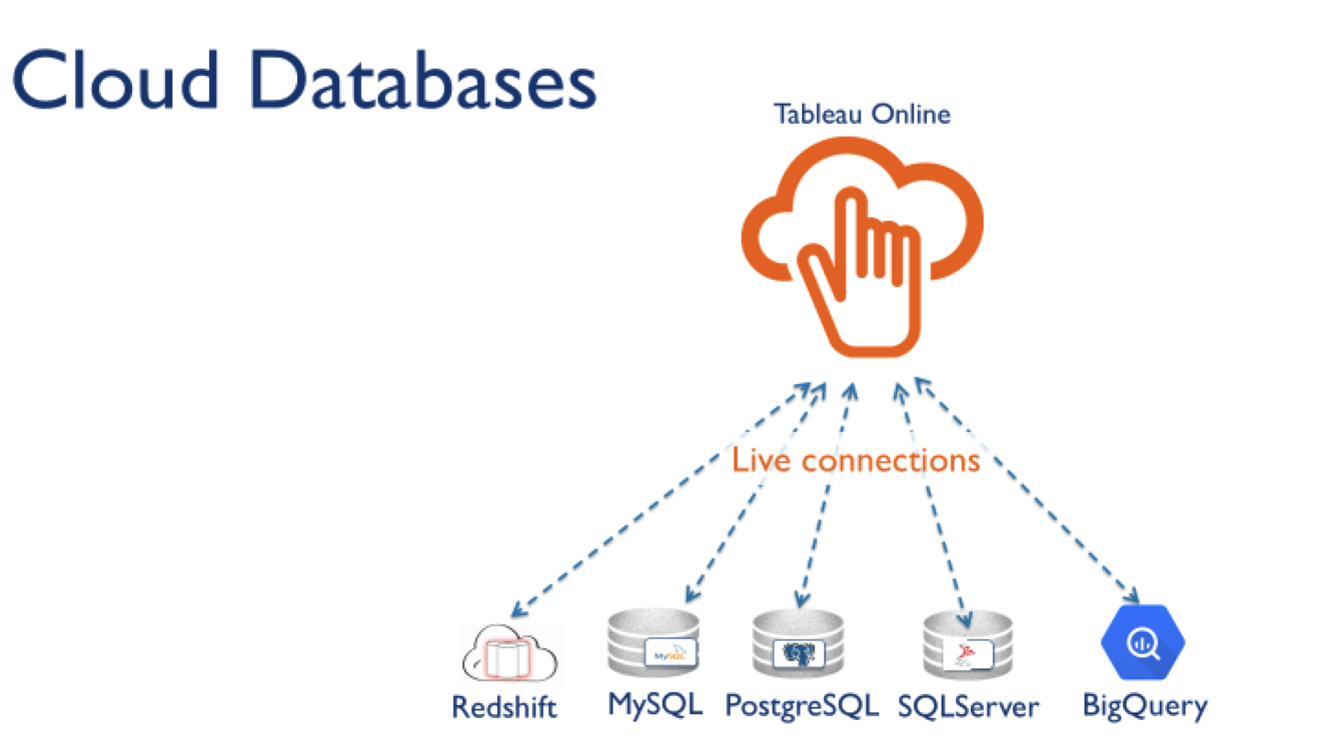

A common misconception is that Tableau Online can only use data extracts. While that once was the case, we’ve made strides in offering live connections for common cloud data sources. Tableau Online currently supports live connections to the following cloud-hosted data sources:

* + Amazon Redshift
  + Amazon Aurora
  + Google BigQuery
  + Google Cloud SQL
  + Hive and Impala on Amazon Elastic MapReduce
  + HP Vertica
  + Microsoft SQL Server
  + Microsoft Azure SQL Data Warehouse
  + Microsoft Azure Database (Marketplace DataMarket)
  + MySQL
  + PostgreSQL
  + SAP HANA
  + Spark SQL
  + Snowflake

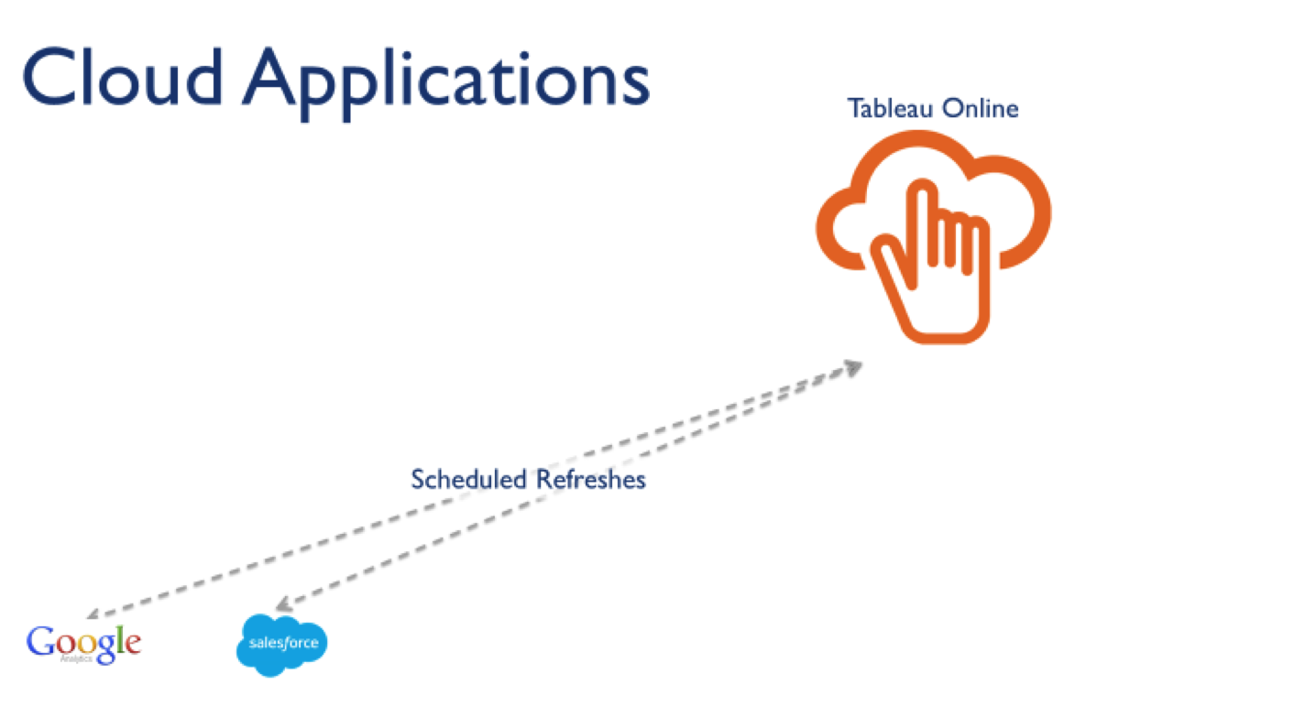

Additionally, you can use data from web applications in Tableau Online. With a scheduled extract refreshes, workbooks can connect to data from the following cloud applications:

* Salesforce
* Google Analytics
* Google Sheets
* Quickbooks Online

All other connections will use extracts and our Online Sync Client to keep data fresh, but we’ll cover that in a future post.

Why use published data sources?

Now that you know what kind of data connections are in your arsenal, let’s talk about how to manage those sources. Each Tableau Online site and project has a Data Sources tab which shows all the data connections published to that area of Tableau Online.

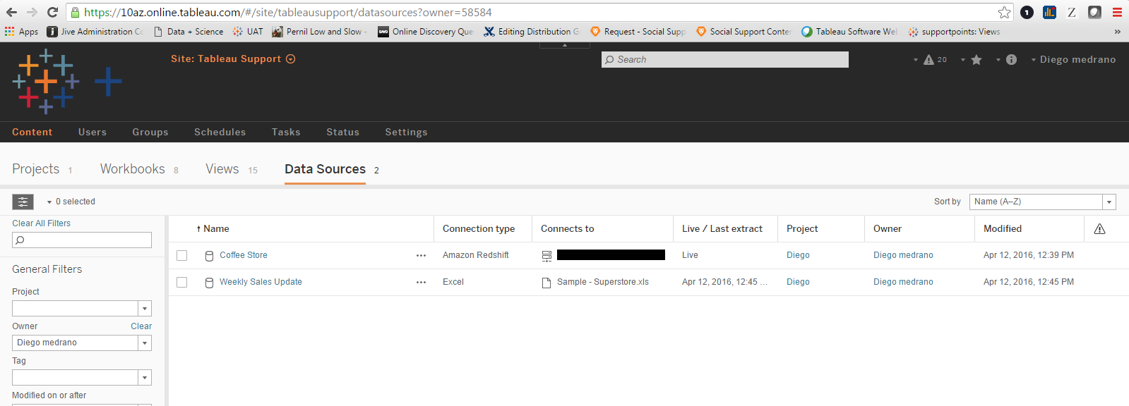

You’ll see whether the connection is live or an extract, and what the originating data source is. In the screen capture above, we have an extract originally based on an Excel file ("weekly sales update”) and a live connection to a cloud-hosted Amazon Redshift database ("coffee store”).

Publishing data sources gives you a centralized, managed location where users can access data. People are no longer required to establish connections to databases themselves. Instead, publishing the data source connection provides simple and secure access through a user’s Tableau Online account.

Publishing a data source to Tableau Online also captures any metadata you’ve built in Tableau Desktop. If you created new calculated fields, groups, sets, or hierarchies in the data pane of your workbook, all these modifications will be reflected in the data source published to Tableau Online. We’ve found this helpful in curating easy-to-use data sources for organizations.

**Requirement: Sales and profit for each product sub category**

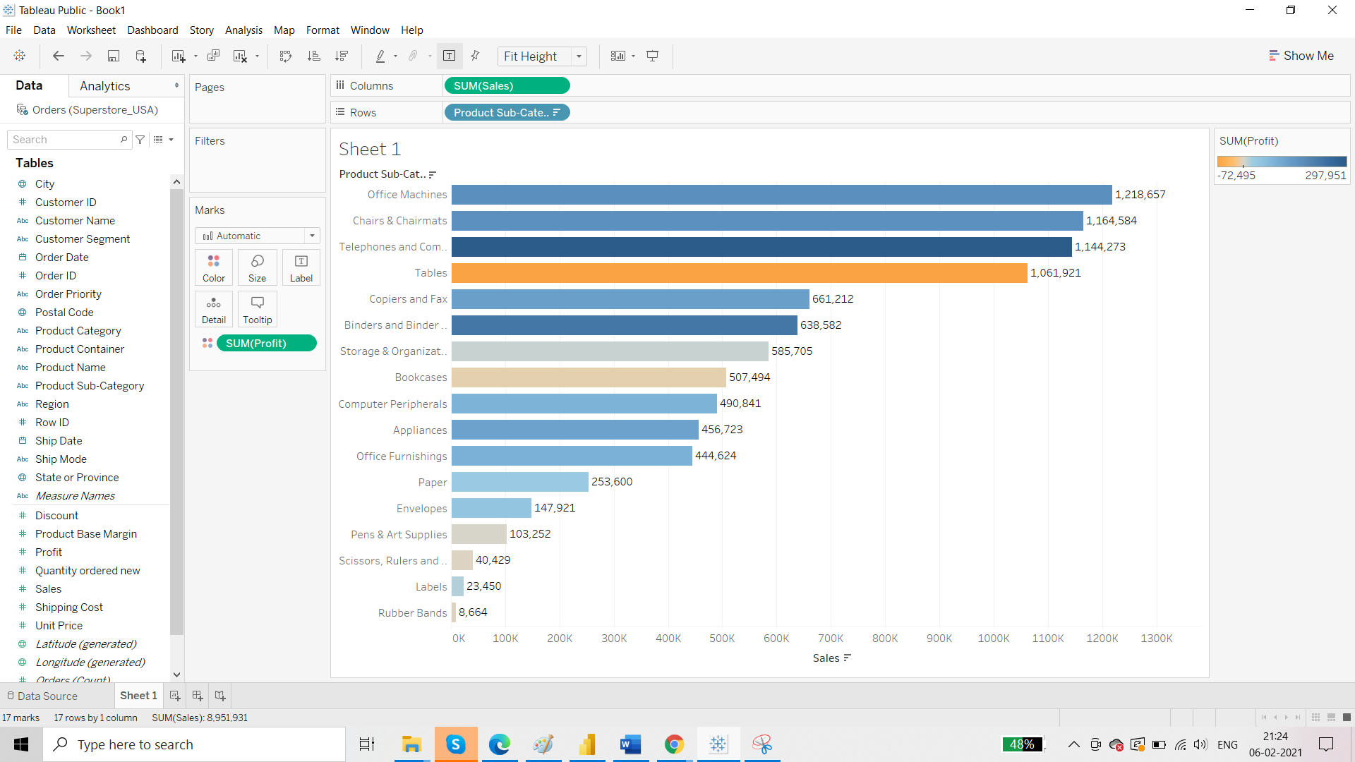

**Requirement: Add currency symbol**

Use option ‘Number Format’

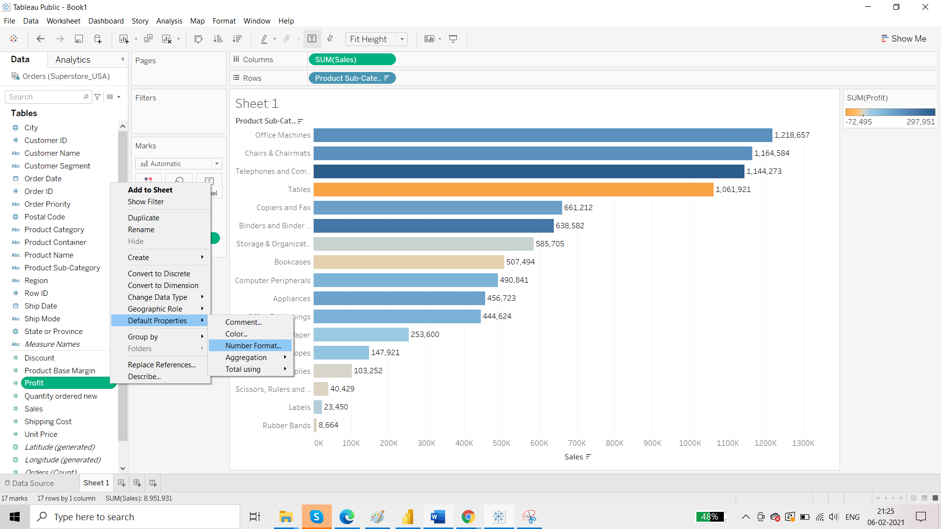

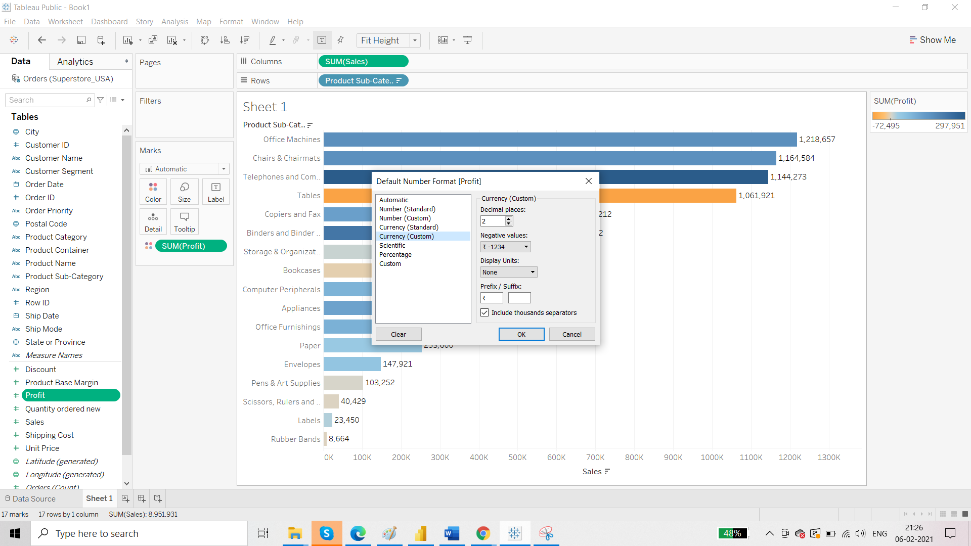

**Requirement: point and click**

Select one measure, hold on ctrl key and select another measure then from ‘show me’ select the visualisation.

**Requirement: Prepare a report on product subcategory where the report should state the profit and average shipping cost for each of the product sub category**

Using point and click:

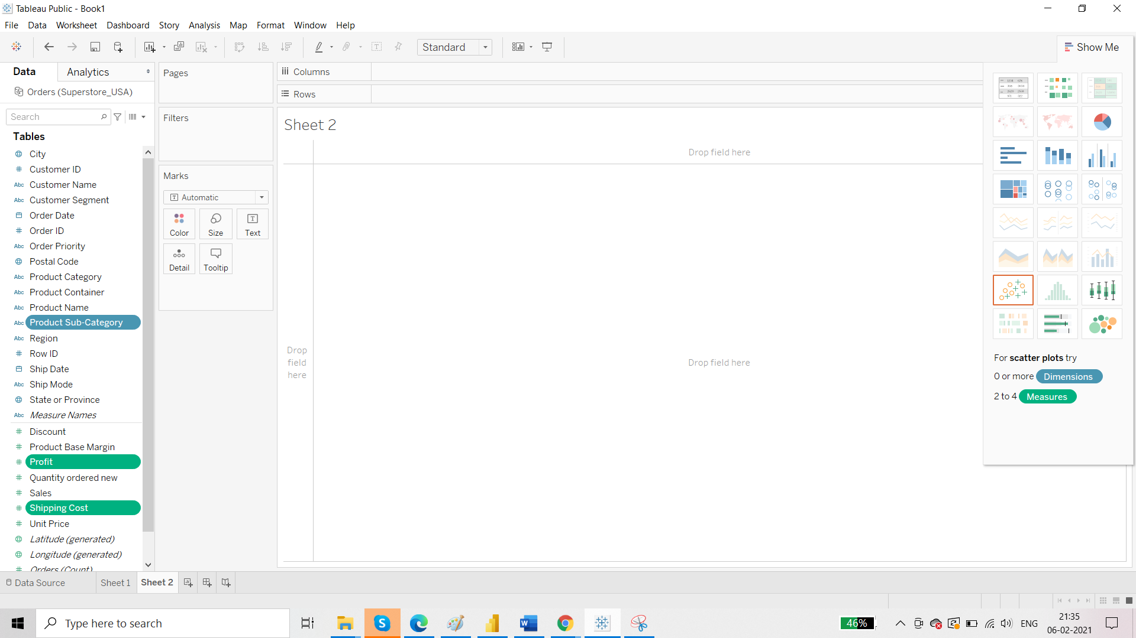

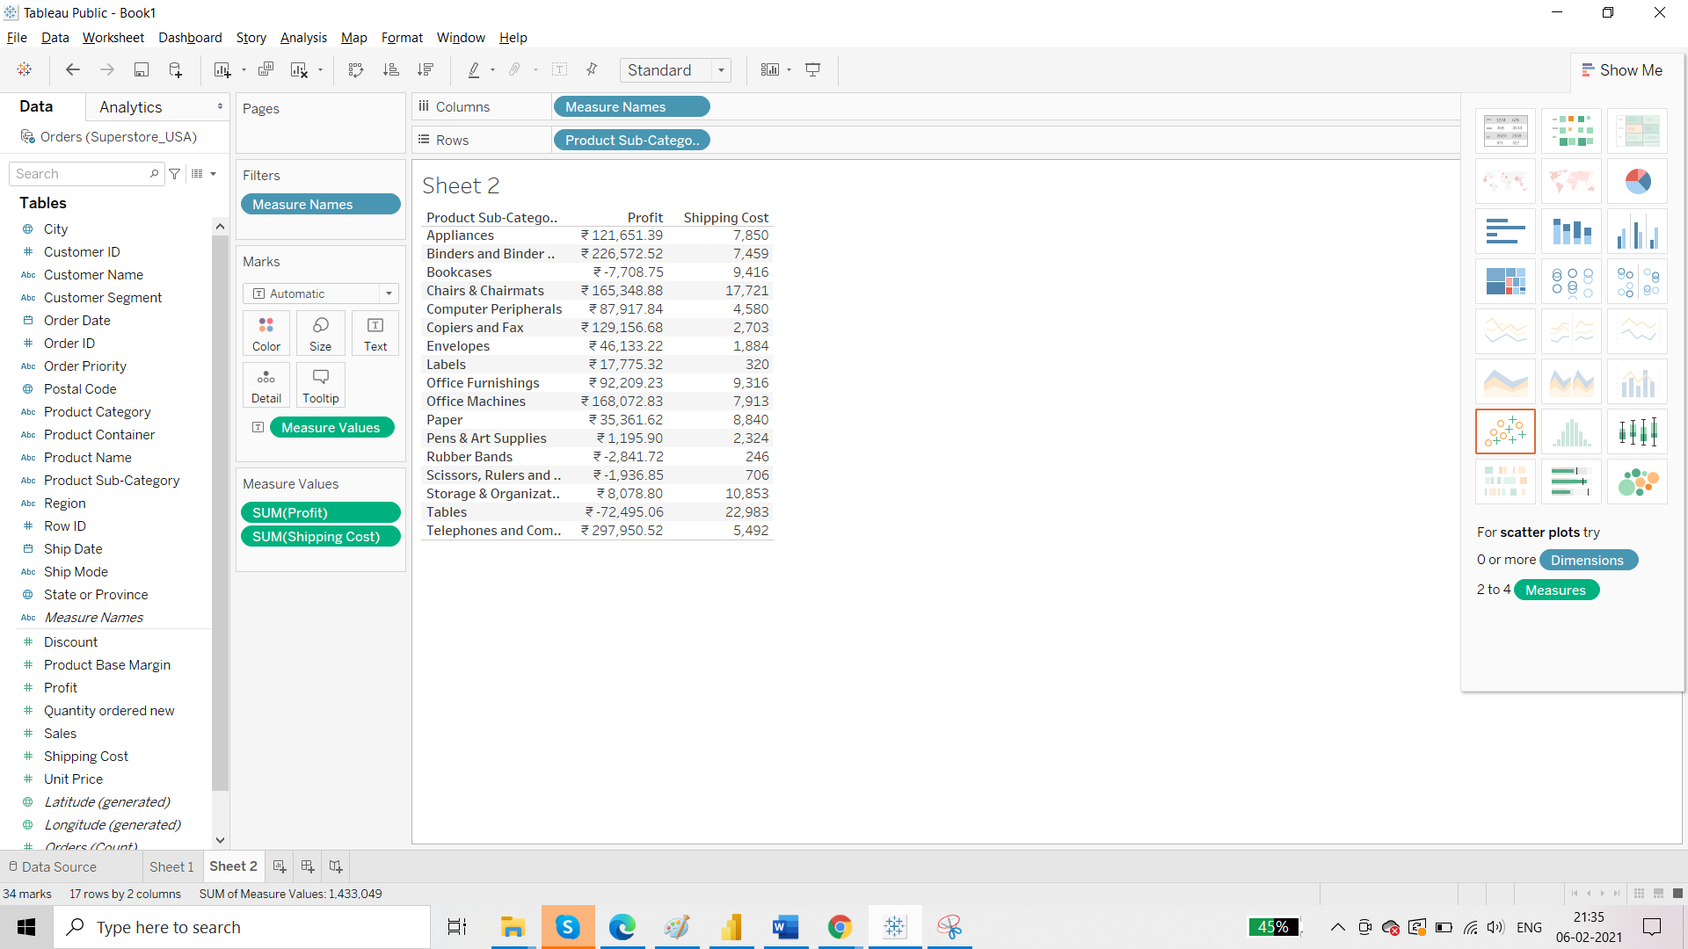

Here we have to format the report:

1. Add the totals

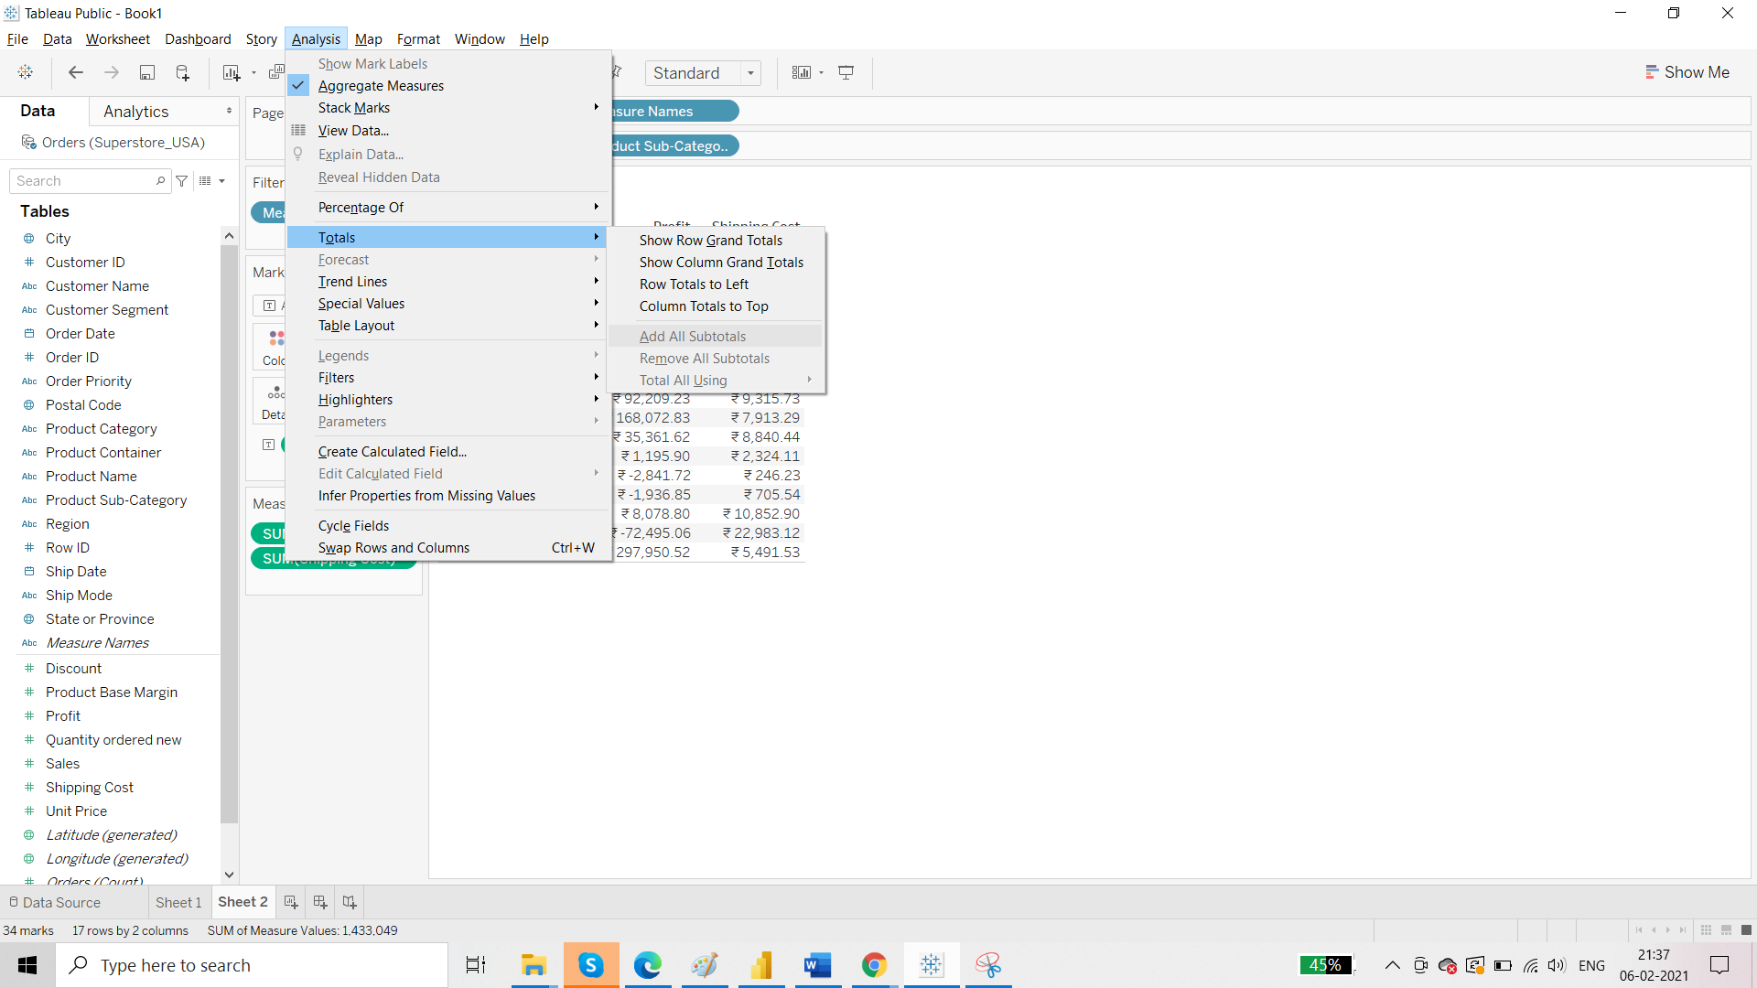

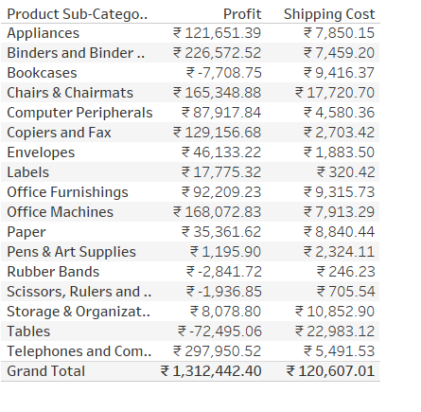

1. Aggregations: change sum to average for shipping cost

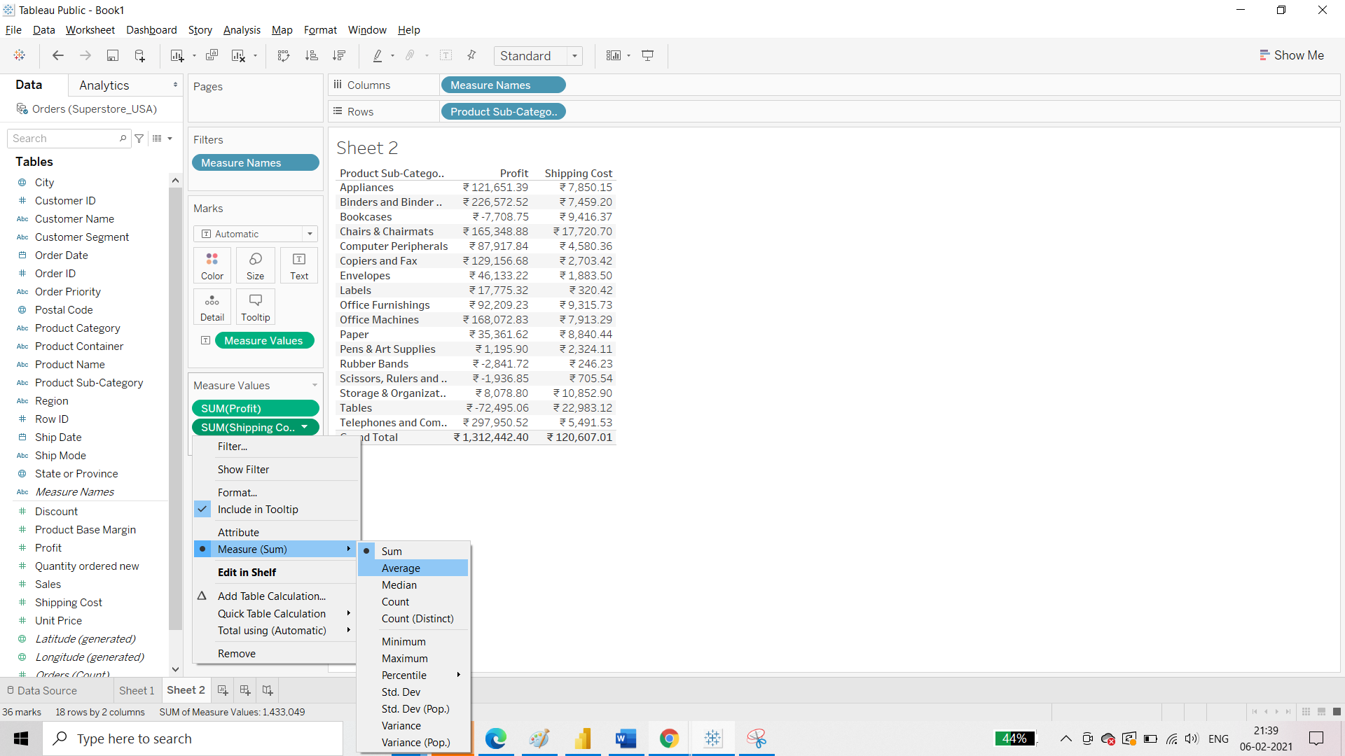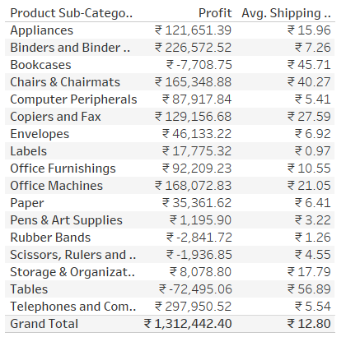

TIP:

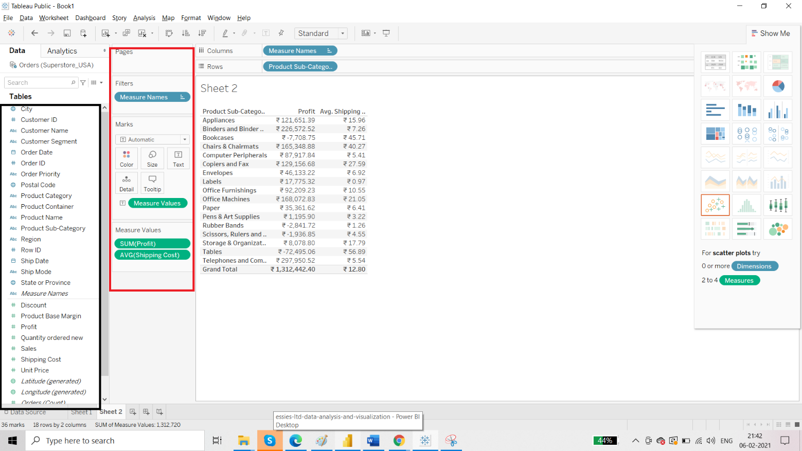

If you change the format of the measure in green area then it is going to be local to that report only. If you change the format from black area, the changes are going to be global that is will be visible to all reports.